ASAPS Meeting 2019 15th Annual CADAVER LAB
New Orleans
Friday, May 17th, 2019
2-6 PM
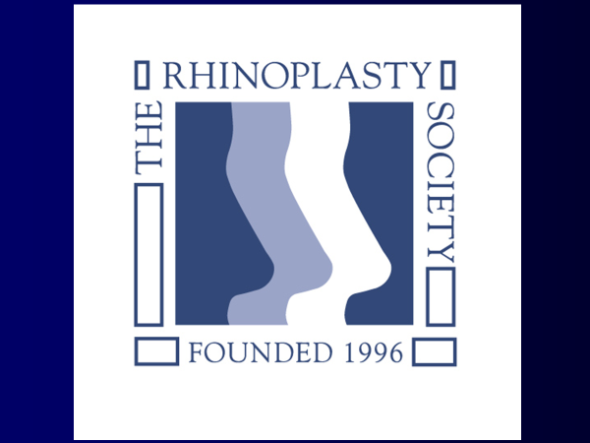

SYLLABUS

Course Director:
Joe Gryskiewicz, MD

Faculty:
Bob Gilman, MD, DMD
Roger Friedman, MD
Rick Beil, MD
Jeff Marcus, MD
Ali Sajjadian, MD
Ashkan Ghavami, MD

Master Dissectors:
Bahman Guyuron, MD
Assistant Bob Gilman, MD, DMD

Preservation Technique demonstration:
Aaron Kosins, MD

Piezo power tool demonstration: Segment 9
R. Laurence Berkowitz, MD

Emeritus Faculty:
Robert Oneal, MD, Paul Izenberg, MD

2-24-19
OUTLINE

INTRODUCTION: Joe Gryskiewicz & Bob Gilman

- MARKING Use Methylene Blue marker
  - Outline Nasal Anatomy
    - lower lateral cartilages/alar cartilages (LLC)
    - upper lateral cartilages (ULC)
    - bones: nasal, maxillary, frontal
  - Incisions
    - trans-columellar stairstep (at the narrowest portion of the columella)
    - trans-columellar inverted “V” (at the narrowest portion of the columella)
    - marginal
  - Tip defining points
  - Planned procedure
    - dorsal profile
    - cephalic alar resection
    - planned osteotomy sites
- INJECTION (Use saline to help with the dissection)
  - External skin dissection planes
  - Nasal septum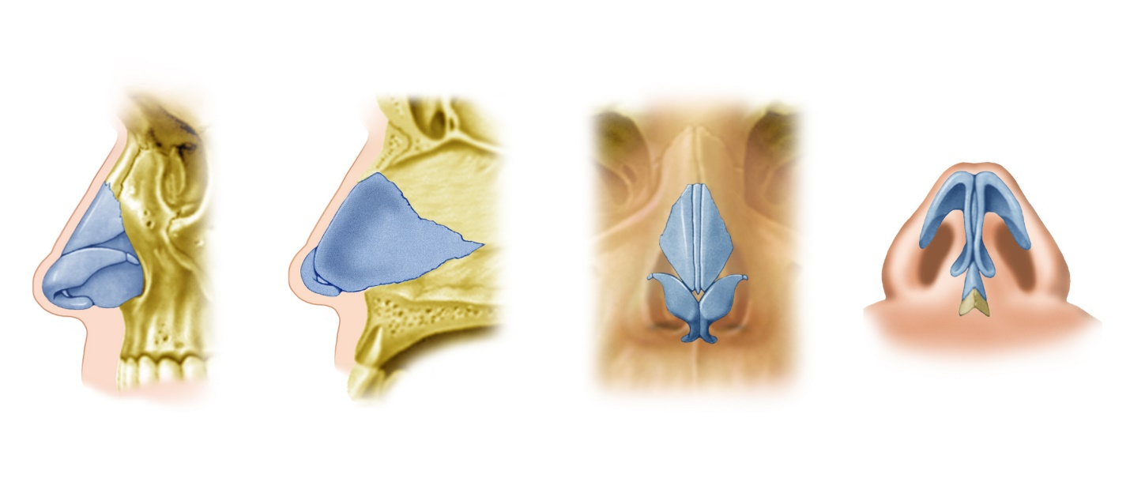
Illustration by Leandro Pellarin

- OPEN APPROACH/SKIN ELEVATION
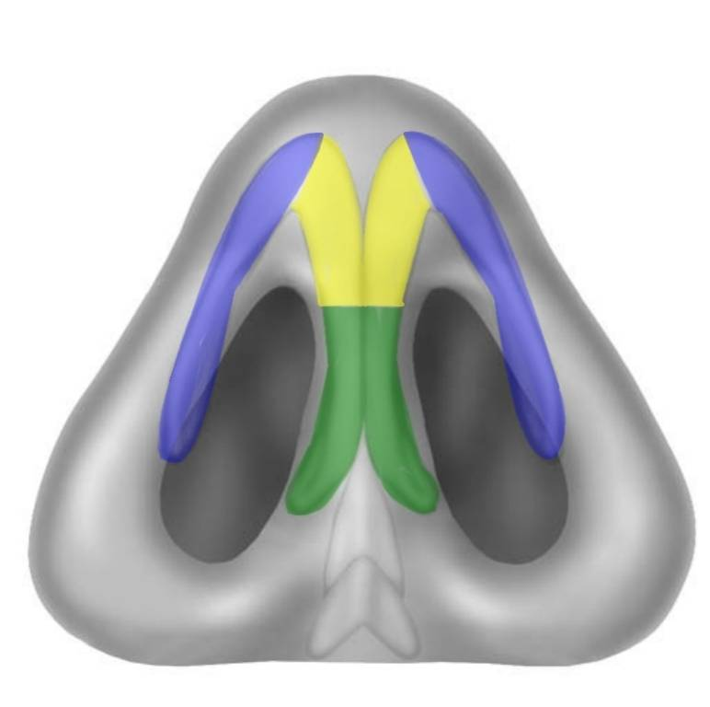 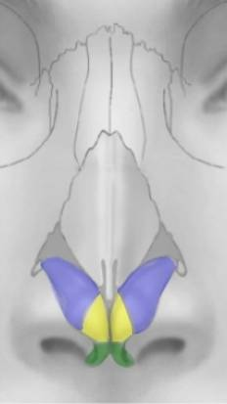llustrations by Hilger

  - Incise the trans-columellar stairstep or inverted “V” incision
    - can use a #11 blade to incise the sharp corners centrally
    - use a #15 for the remaining incisions
    - use caution over the caudal edge of the medial crura
    - extend the incision toward the dome just cephalic to the caudal edge of the medial crura.
  - Elevate the columella using a #4 angled Converse scissors
    - begin centrally and dissect up toward the dome
    - use caution laterally where the skin is directly adherent to the medial crus
  - Elevate the lateral crus
    - identify the caudal edge of the lateral crus
      - the caudal edge corresponds to the end of the hair bearing skin
      - palpate the edge with the end of the scalpel handle
    - evert the edge of the lateral crus with a middle finger while holding a 1 cm double hook at the rim
    - incise along the lateral crural edge toward the dome
    - have your assistant retract the caudal edge of the lateral crus with a small single or double hook
    - use the angled #4 scissors to expose the external surface of the cartilage of the lateral crus
    - continue exposing the cartilage using either scissors or a dry Q-tip working toward the dome
    - straddle the dome with a 1 cm double hook everting with your middle finger
    - use the scissors or scalpel to complete the lateral and medial incisions being careful not to violate the soft triangle facet area
  - Elevation of the dorsum skin
    - insert each tine of a 1 cm double hook into the domes on the mucosal side and retract caudally
    - retract the dorsal skin with another double hook
    - using scissors and a Q-tip expose the superior septal angle
    - continue the dissection using a curved Joseph-Peck scissors or Q-tip toward the radix being sure to stay in the plane directly above the perichondrium and periosteum
      - the extent of the elevation should be only enough to allow for your planned dorsal modifications
      - the extent of elevation should be roughly enough to insert your 5th finger
      - use an Aufricht retractor from this point on to retract the nasal skin
  - Elevation of the periosteum
    - make a transverse incision through the periosteum at the caudal margin of the nasal bones with a #15 scalpel
    - elevate the periosteum with a Joseph elevator

- MIDDLE VAULT COMPONENT SEPARATION
  - Expose the septal angle using a #15 scalpel and scissors
  - Elevate the perichondrium on both sides of the septal angle with a Cottle elevator
    - be sure that you are on the cartilage and beneath the perichondrium
      - score the perichondrium with the sharp edge of a Cottle elevator
      - look for the bluish color of the naked cartilage
      - “when you think you there there’s probably one more layer”

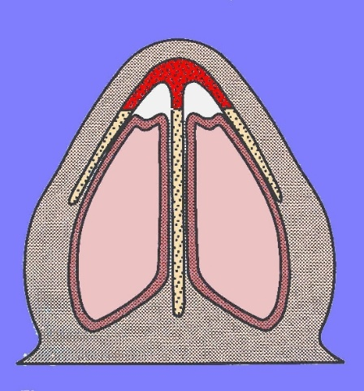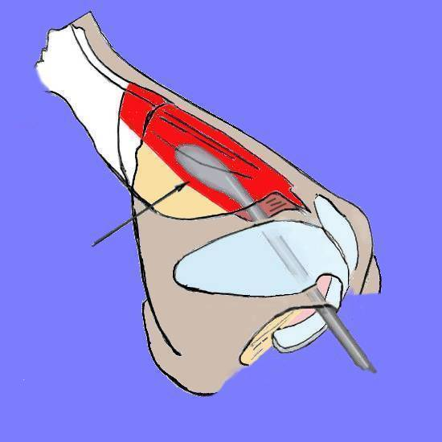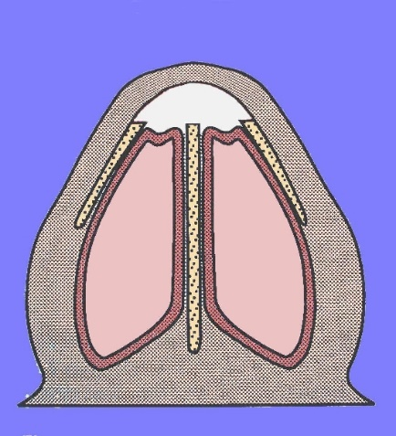
By Gryskiewicz
    - create superior Cottle tunnels on each side of the dorsal septum
      - begin at septal angle
      - elevate toward the nasal bones sweeping the perichondrium from the dorsal septum and its connection to the medial aspect of the upper lateral cartilage
      - continuing in the cephalic direction until you are under the periosteum covering the perpendicular plate of the ethmoid where you should feel the grittiness of the bone
    - separate the upper lateral cartilages from the nasal septum
      - use scissors or #15 scalpel placing the flat of the blade against the septum and cutting dorsally while retracting with an Aufricht
      - proceed from the septal angle toward the nasal bones
- NASAL DORSAL MODIFICATION
  - Bone reduction
    - use a pull rasp to reduce the bony hump
      - be sure that the longitudinal plane of the rasp is held parallel to the desired plane of the proposed dorsal reduction
      - be sure that the transverse plane of the rasp is perpendicular to the sagittal plane of the nose
      - always feel and stabilize the end of the rasp through the skin with the fingers of your nondominant hand
      - use your preoperative markings as a general guide
      - irrigated after rasping to remove bone dust
    - (If available you may use a Piezo tool to remove the bony hump)
    - you may also use a Rubin osteotome to remove the dorsal bony hump
      - reduce the dorsal septum before using the osteotome (see next section)
      - The osteotome is faster than the rasp but easier to over resect
      - place the osteotome against the nasal bones and resting on the already lowered dorsal septum
      - have your assistant “tap-tap” while guiding the osteotome along your predetermined and marked dorsal plane
      - be sure that the osteotome is oriented correctly on both the longitudinal and the transverse plane.
  - Cartilage reduction
    - using a #15 scalpel
      - rest the flat of the blade on the modified bony dorsum with the cutting surface facing toward the tip
      - draw the blade along the planned line of resection from the nasal bone to the septal angle
      - reduce only the septum leaving the upper lateral cartilages available for the fabrication of spreader flaps
    - using a Gorney double-action scissors or other angled scissors
      - rest the tip of the scissors on the nasal bone
      - cut from the septal angle toward the bone along the planned line of reduction of the cartilage
  - Monitoring the dorsal reduction
    - compare your achieved reduction with your markings for planned reduction
    - palpate the dorsum with a wet index finger sliding along the dorsum to ensure smoothness
    - fine tune the bony dorsum with a diamond rasp
    - fine tune the cartilaginous dorsum with a scalpel or scissors
- SEPTOPLASTY AND TURBINATE MODIFICATION
  - Elevate muco-perichondrial /mucoperiosteal flaps
    - start on the convex side if deviation is present or on the side opposite the surgeon’s handedness
    - use a Cottle elevator starting with the sharp side to be sure you are under the perichondrium
    - once under the perichondrium you can use the blunt side in a sweeping motion to elevate the remaining muco-perichondrium. Alternatively, you can use a suction freer elevator
    - continued the elevation under the periosteum of the perpendicular plate of the ethmoid
    - elevate a similar flap on the opposite side if complex modifications are planned, as this decreases the likelihood of perforation of the flap on the opposite side during septal harvest or modification
    - expose the caudal edge of the cartilage if modifications are planned
      - modify caudal septum using either a scalpel or angled scissors
      - the modification could be straight or angled depending on your operative plan
    - be careful elevating at the junction of the cartilage and the vomer as it is easy to perforate the flap at this location
      - carefully separate the cartilage from the vomer using the sharp end of the Cottle elevator
      - alternatively, resect a small rim of septal cartilage by incising 2 mm above and parallel to the junction with the vomer using a septal knife and carefully removing the strip of cartilage with a Cottle elevator. Be sure to leave the caudal most 1 cm of septum attached to the vomer for support
      - if there is a marked spur with deviation of the vomer itself then it may be useful to create inferior Cottle tunnels.
        - Make a .5 cm incision transversely on the medial floor of the nose extending onto the vomer using Bovie cutting current
        - elevate the periosteum from the floor of the nose using a Cottle or a McGinty-West elevator
        - sweep the periosteum off the vomer using a Cottle elevator up to the junction with the cartilage
        - under direct vision elevate the mucoperichondrial flap from caudal to cephalic where the cartilage joins the vomer
  - Modify the cartilage, vomer and/or perpendicular plate of the ethmoid as necessary
    - always leave a minimum of 1 cm of dorsal and caudal septum to maintain support of the middle vault area. More is better.
    - remove or modify obstructing cartilage and/or bone
    - harvest cartilage needed for graft material
    - leave is much cartilage behind as possible
  - Quilt the mucoperichondrial flaps using a 4-0 Plain gut suture with a short Keith needle
    - can be done at the end of the case
    - do it before closing the columella to avoid disrupting your previously placed columellar sutures
  - Inferior turbinate modification
    - cautery (when Dennis bipolar cautery available)
      - thread the Dennis bipolar cautery needles along the inferior turbinate
      - apply current in the setting of 4 to 5 for approximately 30 seconds or until it begins to smoke
    - in-fracture
      - insert the longest nasal speculum between the inferior turbinate and the septum and open the blades crushing the inferior turbinate laterally
      - use a broad narrow elevator such as a “butter knife” to crush the inferior turbinate laterally if there has been previous septal resection to avoid injury to the mucoperichondrial and mucoperiosteal flaps
    - submucous resection
      - make an incision at the caudal border of the inferior turbinate with Bovie
      - elevate the periosteum from the inferior turbinate bone using a Cottle elevator
      - resect the obstructing bone with rongeur
      - closed incision with 4-0 chromic
    - partial turbinectomy
      - use a heavy Mayo scissors to resect the caudal one third of the inferior turbinate including both mucosa and bone
      - rongeur the bone enough to close the mucosa at the caudal edge with 4-0 chromic
    - be sure to place Doyle or Reuter bivalve splints when both turbinate and septal dissections are done to prevent synechiae
- SPREADER GRAFTS AND FLAPS
  - Grafts
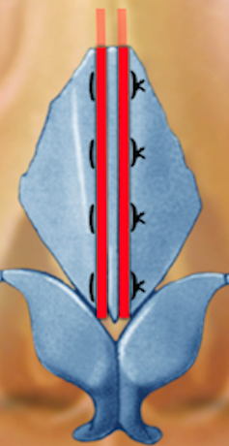 Illustrations by Leandro Pellarin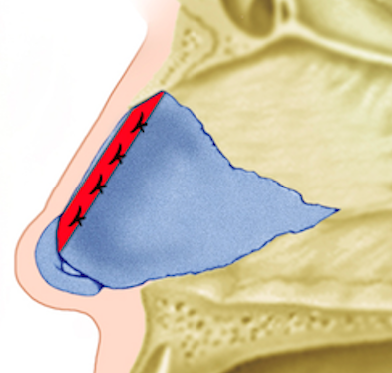Leandro Pellarin
    - from harvested septal cartilage create to spreader grafts each measuring .5 x 3 cm (you can substitute plastic coffee can covers in the lab)
    - position these on either side of the septum along the dorsal edge from just under the bone to the septal angle
    - hold these in place temporarily bypassing a 27gauge needle through and through the graphs and dorsal septum in at least 2 locations
    - suture and position with 2 mattress sutures of 5-0 PDS making sure that the suture is well enough below the dorsal edge to allow final trimming of the dorsum if necessary without compromising the sutures

  - Spreader flaps
    - Mark the outer surface of the upper lateral cartilages at the level of the trimmed dorsal septum
    - score the upper lateral cartilages along this line with scalpel
    - fold the upper lateral cartilages internally at this score line to create a spreader flap on both upper lateral cartilages
    - secure the spreader flaps to the dorsal septum with 27-gauge needles
    - suture them into position with 2 5-0 PDS sutures again placing them far enough away from the dorsal edge of the septum to allow for further dorsal trimming if necessary.
  - Returning the ULC to the dorsal septum with sutures.
    - ULC can be repaired with mattress sutures back to the dorsal septum to preserve the arch of the ULC as it attaches to the septum.
    - Do not simply collapse it up against the septum with sutures.

Illustration by Jaye Schlesinger MFA., MI

- TIP-PLASTY

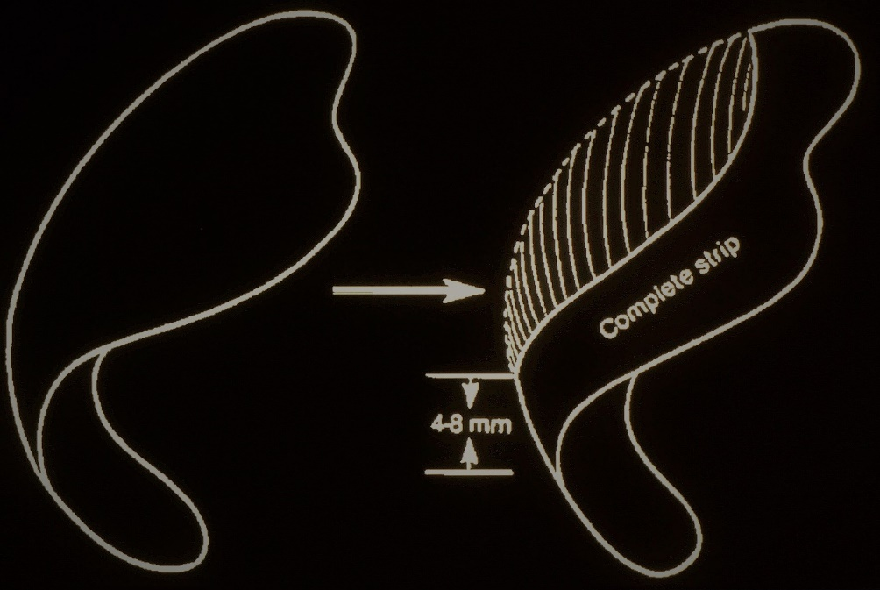

  - With a double hook under both domes make an incision about 4 mm from the dome and 6 mm from the lateral crus so as to create what is called a ‘cephalic ‘island. That island is typically the cause of unwanted convexity
    - It can be discarded at the end of the case if it is not needed for graft material
    - it can be slipped deep to the cephalic border of the remaining 6 mm complete lateral crural strip after elevating the cartilage from the nasal mucosa. It can be used in this manner to thicken and strengthen the lateral crus.
  - Subdomal Graft
    - Dissect a small space deep to the dome on each side
    - Prepare a .2 x .2 x 1.5cm graft from septal cartilage.
    - insert each end of the graft under each dome and use the intervening portion of the graft to control the width and the angle of convergence between the domes.
  - Columellar strut
    - if there is any question about the projection strength of the tip cartilages a strut should be put in between the middle crura at this time.
    - A strut is made from septal cartilage 3 cm long 4 mm wide 1 mm thick
    - With a double hook under both domes or 2 single hooks each under one dome make a tunnel going toward but not necessarily all the way to the anterior nasal spine. Make it wide enough to receive a strut.
    - Insert the strut into the pocket between the medial crura.
    - With a hook under the domes pulling anteriorly while gently pushing the strut toward the nasal spine. Insert two 27-gauge needles to hold the medial crura in position to the strut
    - place 2 mattress sutures of 5-0 PDS to secure the strut in place
  - Transdomal or hemi-transdomal sutures
    - Mark the desired position of the domes on the cartilage
    - Place a 5-0 PDS mattress suture tied medially to accentuate and narrow the dome. Trial and error will tell you where to put it to not only narrow the dome but reduce lateral crus convexity.
    - Watch for wanted inversion of the caudal border of the lateral crus as the knot is tied. If that is a problem, use the hemi-transdomal suture
        - hemi-transdomal sutures are a single suture on the cephalic side of the dome
        - hemi-transdomal sutures narrow only the cephalic side and evert the caudal edge of the lateral crus
      - Interdomal sutures
        - keeps the domes at the proper width and height
          - pass a 5-0 PDS suture from the cephalic aspect of one middle crus to the other at about 3 mm below the dome height.
          - Do not over narrow the tip
      - Narrowing the medial crura
        - Sutures can also be placed on the caudal side of the middle crura to keep the columella narrow.
        - Excessive flair of the foot plates of the medial crura
          - transect the medial crura within #11 blade at the point at which they begin to flare
          - Place a through and through mattress suture to medialize the foot plates
          - use of 4-0 plane catgut suture on a small Keith needle with the knot tied externally in the vestibule
      - straightening convexity of the lateral crura

  - Lateral crural contours sutures
    - using a 5-0 PDS suture on a small needle, take a bite on one side of the most convex portion of the lateral crus going perpendicular to the long axis
    - A second bite is taken about 5 mm away from the first (also perpendicular to the long axis of the lateral crus)
    - tie the suture loosely just enough to correct the convexity and avoid
    - causing collapse, the lateral crus.
    - place a second lateral crus mattress suture and even a third to ultimately get a completely flat lateral crus.
  - Lateral crural strut of Gunter
    - create a thin straight graft .3 x 2cm from septal cartilage
    - Undermine the cephalic edge of the lateral crus to make room for it and slip it deep to and longer than the convexity of the lateral crus to straighten it out.
- Tip stabilization with Crural septal sutures
  - Secures and controls the nasal tip length and rotation
  - Tip height should be about 6 mm above the dorsal height in patients with average skin thickness
  - A 5-0 PDS suture is placed from the cephalic part of the lateral crus to the dorsal septum.
  - If the lateral crus does not touch the dorsal septum because of the cephalic lateral crus resection, the suture should be a spanning suture.
  - A tight suture would create alar retraction.
  - Flip the skin flap back and try to make judgments as to the proper location of the tip height, and rotation. Trial and error is commonly done here.
- Tip Grafts
  - Projection and tip shape cannot always be accomplished with sutures.
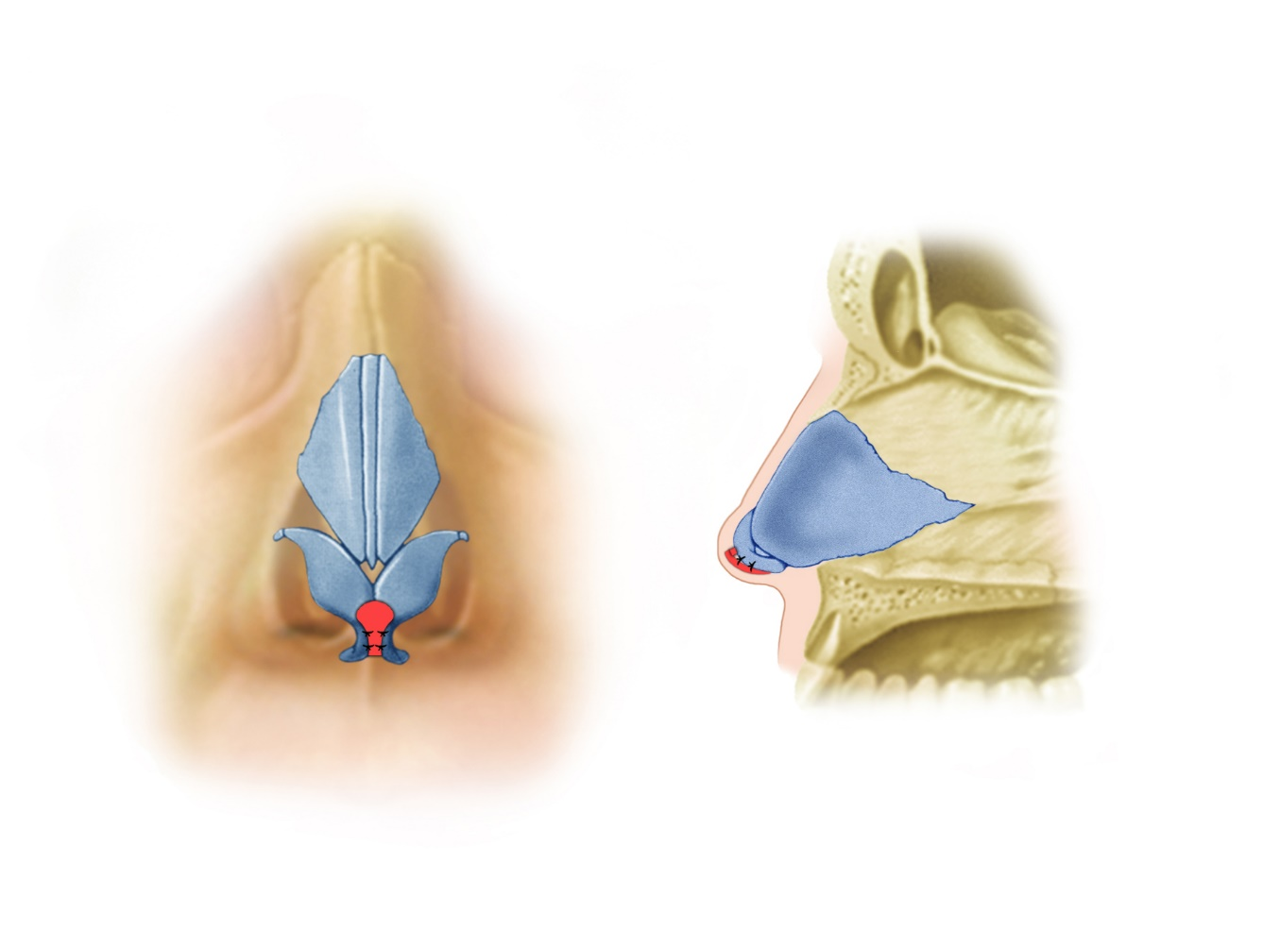
Illustration by Leandro Pellarin

  - Shield graft
    - Has the exact anatomic configuration of the normal nasal tip.
      - Has a component that represents the domes
      - Has a component that represents the middle crura.
      - Easy to carve a graft from septal cartilage that has the surface shape of the domes and middle crura
    - Apply it to the surface caudal to the domes and middle crura and hold with a #30 needle.
    - Secure with 5-0 fast plain catgut suture.
    - To give it more projection apply a small “hidden” spacer graft deep to the shield graft and secure if necessary with the 5-0 plain fast gut suture

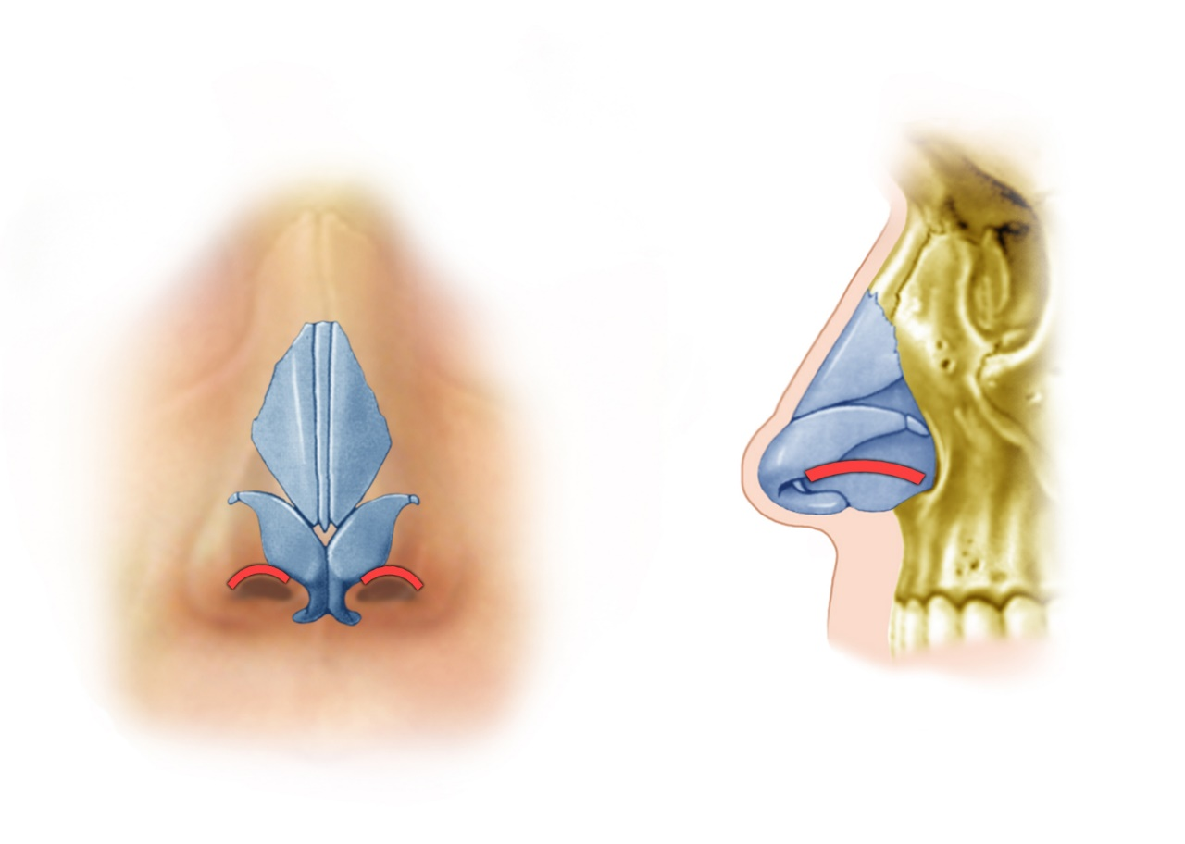
Illustration by Leandro Pellarin

- Rim Grafts
  - Indicated if there is a concavity to the rim or if it is weak to palpation
    - create a 2cm graft .3cm wide no more than .1cm thick
    - create a tunnel right at the rim using a small Iris scissors taking care not to perforate the skin
    - the tunnel should extend well beyond the area of notching or weakness
    - the graft is inserted into a tunnel and can be secured with a single 5-0 fast absorbing playing gut suture
Illustration by Jaye Schlesinger MFA., MI

- Alar Strut Grafts or Lateral Crural Strut Grafts
  - This graft is designed to add support to the lateral crura in cases where there is external valve incompetency
  - It is a hidden graft placed between the lateral crural cartilage and the nasal mucosa
  - It is meant to overlap the pyriform aperture to sit on the facial side of the pyriform and thus prevent the lateral crus from collapsing
    - create a tunnel between the nasal mucosa and the lateral crural cartilage from just lateral to the dome all the way down to and over the pyriform aperture using an Iris scissors or a number 4 Converse scissors
    - carve a piece of septal cartilage approximately .3 by a 2.5 cm
    - placed the strut in the tunnel being sure that it rests on the external surface of the pyriform aperture
    - secure with a 5-0 PDS suture

- OSTEOTOMIES
  - (Can also use Piezo for Osteotomies)
  - Medial oblique
    - use right and left curve guarded osteotomes
    - place the right osteotome at the apex of the space between the nasal septum in the right nasal bone
    - use the curve of the osteotome to help direct the osteotomy obliquely toward the medial canthus
    - advance the osteotome no more than 1 cm feeling the ball of the osteotome through the skin with your finger at all times while your assistant “tap-taps” with a mallet on your queue
    - repeat on the opposite side
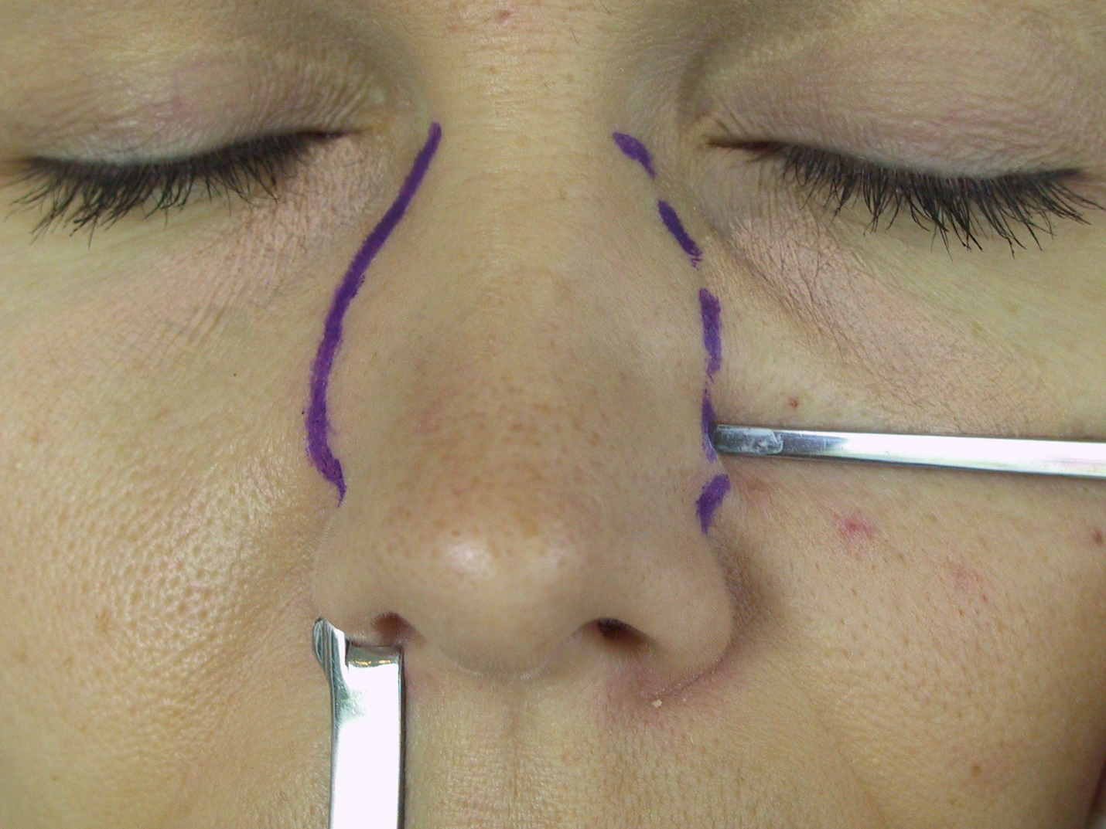
Gryskiewicz

  - Lateral osteotomy using a curve guarded osteotome
    - make a .5cm incision in the lateral vestibular mucosa just caudal to the inferior turbinate and right over the pyriform rim with a Bovie
    - elevate the periosteum along the desired path of the lateral osteotomy with the Joseph elevator
      - “low to low” if you wish to narrow the nasal bony base
      - “low to high” if you only wish to close the open roof after hump reduction
      - can vary the position of the osteotomies including the use of multiple osteotomies according to the goals of the operation
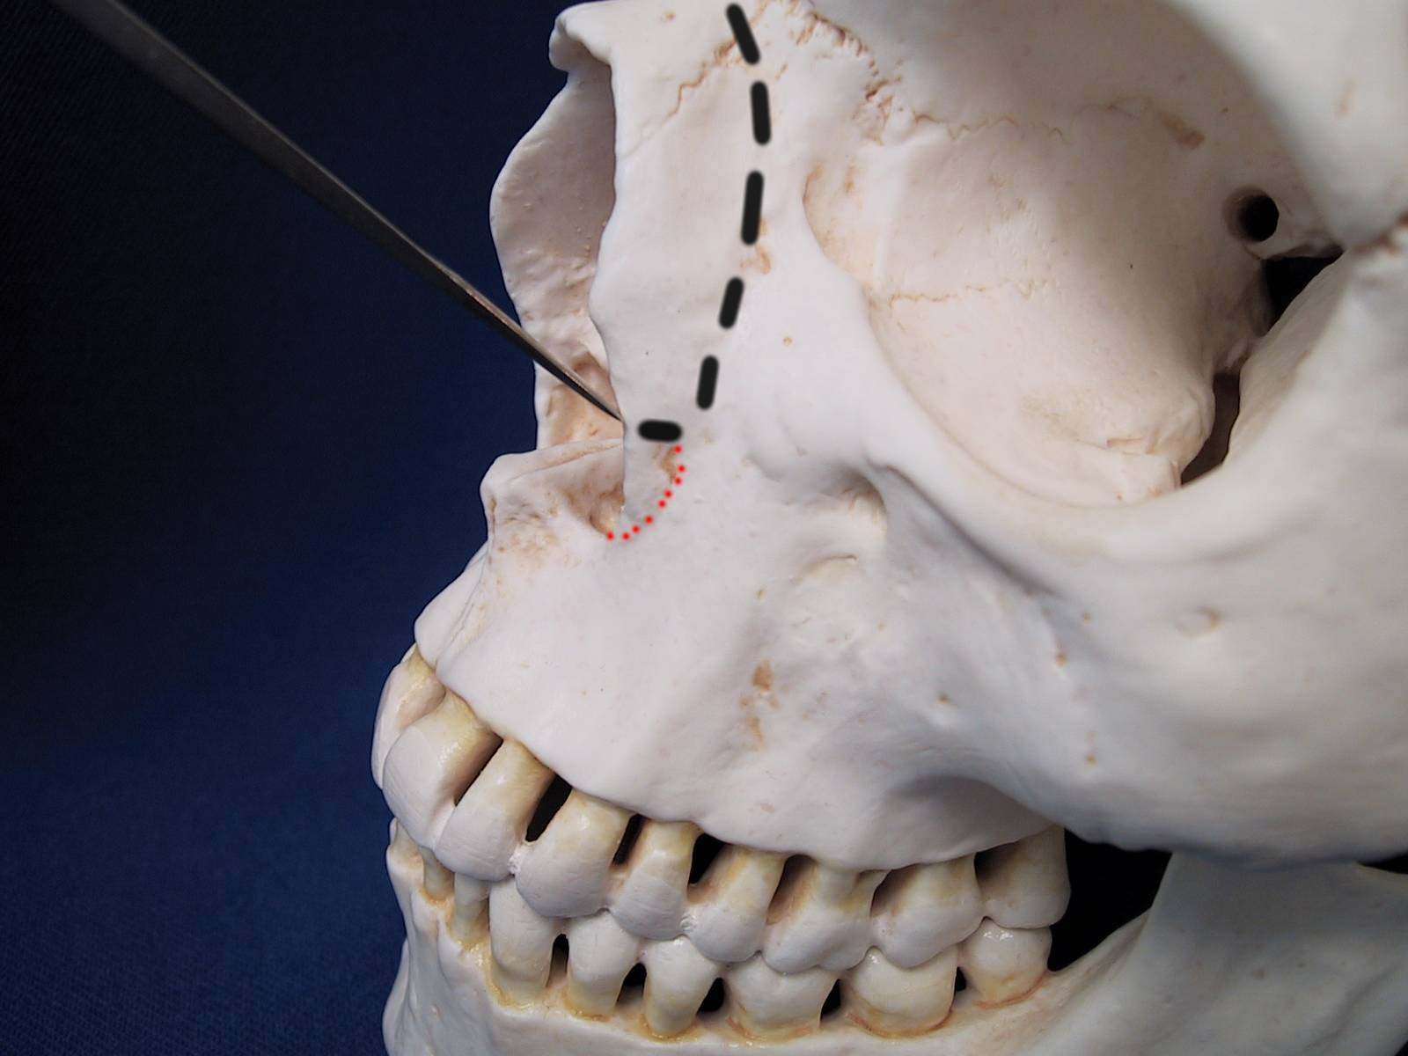
Gryskiewicz
    - preserve Webster’s triangle where the lateral alar crus attaches
    - engage a curved osteotome at the pyriform rim and monitor its position with your finger as the assistant “tap taps” with a mallet. Stop short of the medial oblique osteotomy to leave an area that will green stick and provide stability for the bony segment
    - medialize the nasal bone with gentle digital pressure
  - Lateral osteotomy using percutaneous 2 mm osteotome
    - gently tap the osteotome through the skin with the long axis parallel to the relaxed skin tension lines at the midpoint of the planned lateral osteotomy
    - once through the skin turn the osteotome so that the long axis is parallel to the planned osteotomy
    - preserve Webster’s triangle
    - begin the osteotomy at the pyriform edge and have your assistant “tap-tap“ with a mallet
    - if the osteotome gets stuck in the bone always free it by rocking parallel to its long axis to prevent breaking the tip off in the bone
    - walk the osteotome up the planned osteotomy line again stopping short of the previous medial oblique osteotomy
    - medialize with gentle digital pressure
    - if the bones do not easily move go over the osteotomy again until they can be moved with gentle pressure.

- NASAL CLOSURE

  - 6-0 Nylon (or plain) for the columella
  - 5-0 plain or chromic for the marginal incision.

- ALAR BASE RESECTION
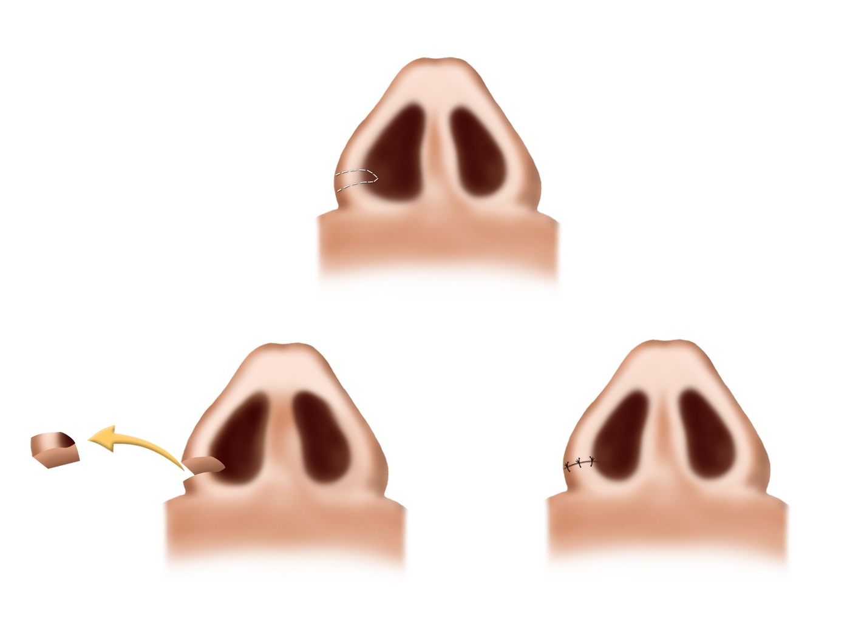
Illustration by Leandro Pellarin

  - Conservative and seldom more than 3-4 mm
  - Reduce alar flare
    - Shorten the lateral ala
    - Excise a wedge from the alar cheek junction dorsally
    - Suture with 5-0 monocryl deep and 6-0 nylon or chromic on the skin
  - Reduce the alar base width
    - Decrease the width of the nasal sill
    - Wedge excision of the lateral sill beginning at the alar sill junction and extending medially.
    - Close in a layered manner using 5-0 Monocryl deep and 6-0 nylon or chromic in the skin
  - Reduce both the alar base width and flare
    - center the excision on the alar cheek junction removing tissue from both above the junction and medial to the junction thus both shortening the ala to correct the flare and shortening the sill to narrow the alar base
    - close in a layered manner using 5-0 Monocryl deep and 6-0 nylon or chromic in the skin

- CLOSED RHINOPLASTY

I CLEARLY DEMONSTRATE THE ENDONASAL APPROACH AT THE END OF THE INSTRUCTIONAL DVD.
(IF ANY PARTICIPANT WANTS TO PRACTICE THE CLOSED/ENDONASAL APPROACH TO THE TIP – PLEASE HAVE DRS. BOB GILMAN or GEOFF KEYES GIVE YOU A HAND. SEE INSTRUCTIONS BELOW. DO THE CLOSED APPROACH BEFORE YOU OPEN.

- Delivery Technique (Right Side)
The delivery approach consists of 2 incisions – the “marginal incision” at the inferior border of the lateral crura and the “intercartilaginous” incision at the scroll juncture between the lateral crura and the upper lateral cartilage.

- Marginal Incision. Retract the right alar rim with the double hook. Use your middle finger on the external skin over the lateral crura to help evert the vestibular skin and visualize the caudal edge of the lateral crura. The knife handle can be used to palpate the border of the alar cartilage. There is an approximate correlation between the caudal edge of the lateral crura and where the vibrissae disappear. Remember that the caudal edge curves cephalically away from the alar rim as you proceed laterally. I tend to think of the marginal incision as consisting of 3 parts: lateral crus, domal and columellar. The lateral crus is made from near the dome and proceeds laterally hugging the caudal border of the lateral crura. Then the double hook is readjusted, and pressure put directly over the dome to allow a lateral to medial dissection beneath the dome – one must avoid injury to the soft tissue facet or the underlying alar cartilage. Next, the incision continues down along the columella with the distance depending upon how much exposure is required – minimum in most delivery approaches, but down to the midcolumellar level when an open approach is planned.

- Intercartilaginous Incision. Place the double hook on the right alar rim. Place a single hook on the right side of the columella. Retract the nasal rim cephalically until a ridge appears intranasally at the limen nasae. Place the incision 1-2 mm caudal to the ridge using a #15 blade – cutting from the septum out laterally for about 10mm. Then, turn the knife over and cut medially to the septum and then down inferiorly into a “transfixion incision.” This extension will allow exposure of the septal angle. One should dissect cephalically for a distance of 5-10mm until the cartilage vault is reached.

- Delivery and Cartilage Resection. Use the double hook to retract the alar rim. Then using Stevens dissecting scissors begin dissecting between the anterior surface of the lateral crura and the overlying skin at the midpoint of the lateral crura. Elevate the overlying skin centrally, then laterally, and then after readjusting the double hook begin the dissection over the domal area. The amount of dissection medially depends on the planned extent of cartilage resection in the dome and middle crura. Once the cartilage is completely free and the scissors have penetrated thru the intercartilaginous incision, then the cartilage can be delivered. It is often easiest to deliver the lateral crura with a mosquito hemostat placed first thru the intercatilaginous incision and then the marginal incision. Once the cartilage is delivered it can be resected. One should make sure that there is sufficient medial mobilization. Then using a caliper and a marking pen, mark a 4-5mm rim strip paralleling the caudal border of the lateral crura. Place a single skin hook in the medial part of the skin to allow maximum exposure. Then resect the excess cephalic lateral crura from medial to lateral, carefully preserving mucosal lining. Clinically, it may be smart to inject the underlying mucosa prior to eversion. Save the excised cartilage for insertion as a Peck onlay graft.

- Transcartilaginous Technique. (Left Side)
The transcolumellar technique is based on the “intracartilaginous or transcartilaginous” incision. The critical factor is that the incision penetrates both mucosa and underlying cartilage at the same time and thus defines amount of cartilage to be removed. It is critical that the incision be placed at least 4 mm above the caudal border of the lateral crura. The incision itself is quite similar to the marginal incision. The alar rim is retracted upward. The mucosa is reinjected with local anesthesia once the location of the incision has been determined. The incision starts medial and sweeps laterally preserving at least 4-5mm of caudal lateral crura. Next, the double hook is place more medially and the assistant can retract the columella with a single hook. The incision continues medially beneath the dome and down into the membranous septum.
The overlying skin is then elevated from the superior surface of the cephalic lateral crura. One dissects superiorly above the scroll area. Next, the mucosa is dissected off the underlying surface of the lateral crura – a maneuver greatly facilitated by prior injection of local anesthesia. One begins centrally, then laterally and finally into the more delicate area medially. The cartilage will easily come out by retracting on the lateral crura with Adson-Brown forceps once the level of the upper laterals are reached – one often sees small sesamoid cartilages at this juncture. Again, save the cartilage for future grafts. One should then dissect an additional 5-10mm until the cartilage vault is reached.)

SUGGESTED INSTRUMENT LIST

Syringes: 5 cc, 3 cc
needles: 25 long, 27 long
Q-tips: wooden handle
2 double hooks: 1 cm
forceps: Adson-Brown, Adson
Cottle elevator
speculum: Vienna, medium
Aufricht retractor
Joseph elevator
Converse number 4 scissors
Joseph-Peck scissors curved and straight
Mayo scissors
pull rasp
curved guarded osteotome: right and left
osteotome: 2 mm
Mallet
suture: 4-0 nylon PS-2, 5-0 nylon P-3, 6-0 nylon P-1
plastic copy can cover - the dissection will go quicker if you bring a baggie with precut coffee can lid “grafts” in the shape of: spreader grafts, medial crural strut grafts, lateral crural strut grafts and tip grafts.

ADDITIONAL SUGGESTIONS

Scrubs
alcohol-based hand wash
marking pens

